The Evelyn and Jim Morris Memorial Scholarship
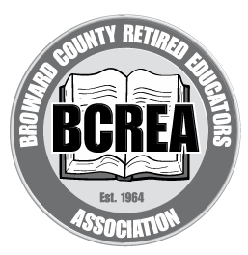

Broward County Retired Educators’ Association

2025 Application

This $1000 scholarship is through the generosity and in memory of Evelyn and Jim Morris, former Broward County educators. This scholarship is given to current employees of Broward County Public Schools and may be used for undergraduate, graduate, or technical programs.

Directions:
- 1. Fill out the application COMPLETELY. Incomplete applications will not be considered. Application forms are also available on the BCREA website:
- https://www.browardrea.org.
Open the scholarship tab on the left and then select the Morris Scholarship.

- Email your completed application packet by 11:59 PM on March 20, 2025, to addiecares@outlook.com.

- In the subject field, type your last name, first name, and Morris Scholarship.

Application:

- Name_________________________________________________________________________

Home Phone:___________________ Cell Phone______________________________________
Home Address ___________________________City______________________ Zip_________
E-mail Address__________________________________________________________________

- Are you a Broward County Public Schools employee? Yes ___ No_____

Work Location__________________________ Position________________________________

- Work Experience: List and describe your present and former work experience, including your dates of employment.
________________________________________________________________________

________________________________________________________________________

______________________________________________________________________________

_____________________________________________________________________________

______________________________________________________________________________
- The accredited university, college, or school I will be attending:
_____________________________________________________________________________

Term__________________________________________________________________________

Morris Scholarship funds are available July 1, 2025–June 30, 2026.

- List your past and present participation in school, community, and/or volunteer activities. Attach additional pages as needed.

ACTIVITY YOUR PARTICIPATION DATES

____________________________________________________________________
____________________________________________________________________
____________________________________________________________________
____________________________________________________________________
6. Enclose as a separate page: Why are you applying for this scholarship? What are your goals? This statement must be typed, one-page double-spaced with a word limit of 800 words.

- Also, please enclose two (2) letters of recommendation with your complete application. One letter must be from your current supervisor.

This application must be FULLY COMPLETED, including your career essay and two (2)
recommendation letters. Incomplete applications will not be considered.

Good Luck!

